TUGAS BAB 3

Berikut adalah programnya

import 'package:flutter/material.dart';

void main() {

runApp(MyApp());

}

class MyApp extends StatelessWidget {

@override

Widget build(BuildContext context) {

return MaterialApp(

title: 'E-Commerce UI',

home: HomePage(),

);

}

}

class HomePage extends StatelessWidget {

@override

Widget build(BuildContext context) {

return Scaffold(

appBar: AppBar(

title: Text('E-Commerce UI'),

),

body: SingleChildScrollView(

child: Column(

children: [

Container(

height: 200,

color: Colors.lightBlue,

child: Center(child: Text('Toko Baju Anak ', style: TextStyle(color: Colors.white, fontSize: 24))),

),

// Tambahan tampilan di bawah

Padding(

padding: const EdgeInsets.all(16.0),

child: Text('Produk Populer', style: TextStyle(fontSize: 20, fontWeight: FontWeight.bold)),

),

// GridView untuk produk

Container(

height: 300, // Tinggi GridView

child: GridView.builder(

gridDelegate: SliverGridDelegateWithFixedCrossAxisCount(

crossAxisCount: 2,

childAspectRatio: 0.75,

),

itemCount: 4, // Jumlah item produk

itemBuilder: (context, index) {

return ProductCard(index);

},

),

),

],

),

),

);

}

}

// Custom Widget untuk kartu produk

class ProductCard extends StatelessWidget {

final int index;

ProductCard(this.index);

@override

Widget build(BuildContext context) {

return Card(

elevation: 4,

margin: EdgeInsets.all(8),

child: Column(

children: [

Image.network('https://encrypted-tbn0.gstatic.com/images?q=tbn:ANd9GcQhKvlWlier2NjaPLe0lSRakCjJe4D67IHHEw&s'), // Ganti dengan gambar yang berbeda

Padding(

padding: const EdgeInsets.all(8.0),

child: Text('Produk $index', style: TextStyle(fontSize: 18)),

),

ElevatedButton(

onPressed: () {},

child: Text('Tambah ke Keranjang'),

),

],

),

);

}

}

Berikut adalah hasil tampilan dari programnya

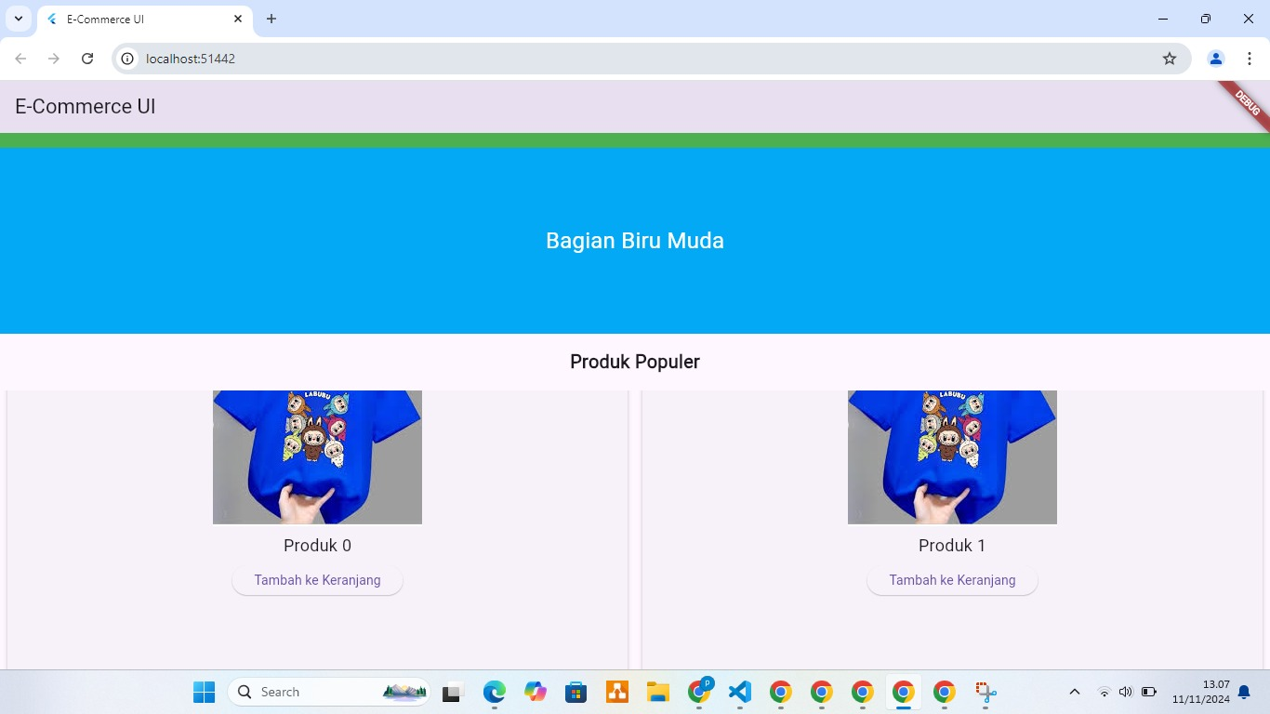

Berikut referensinya

<https://flutter.dev/docs/development/ui/widgets-intro>

<https://api.flutter.dev/flutter/widgets/GridView-class.html>

<https://flutter.dev/docs>